**Testing Report:**

Section I: Unit Tests

a) ML algorithms

Below is some of the content of the CSV file entered into the ML algorithm:

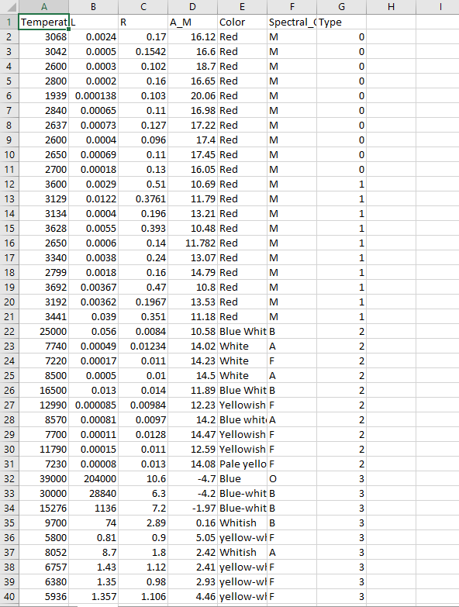

Here is the same file after it has gone through the ML algorithm:

w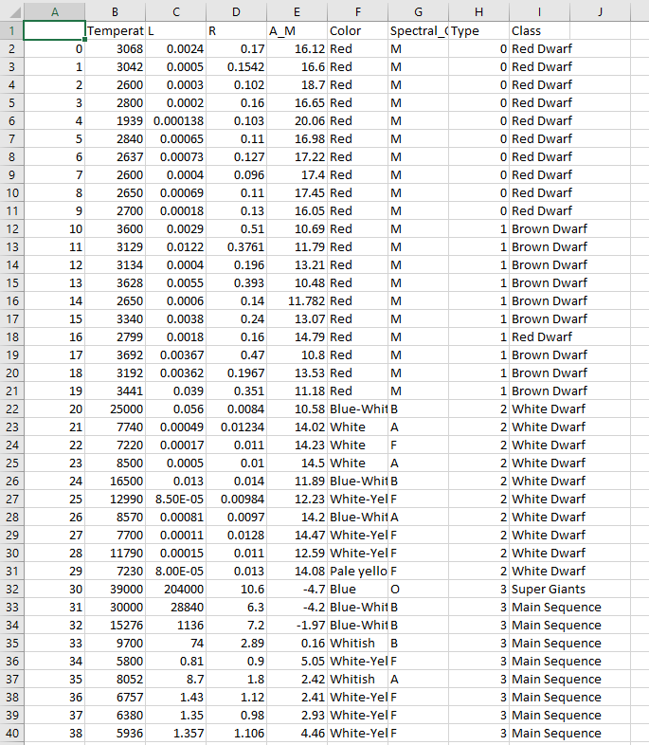

b) Graph algorithms

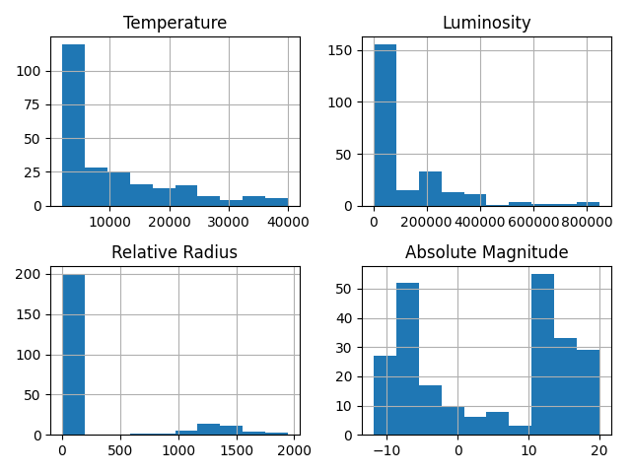

Above is the temperature, luminosity, relative radius, and absolute magnitude of the stars based on the ML algorithm. The results have been condensed into a graph.

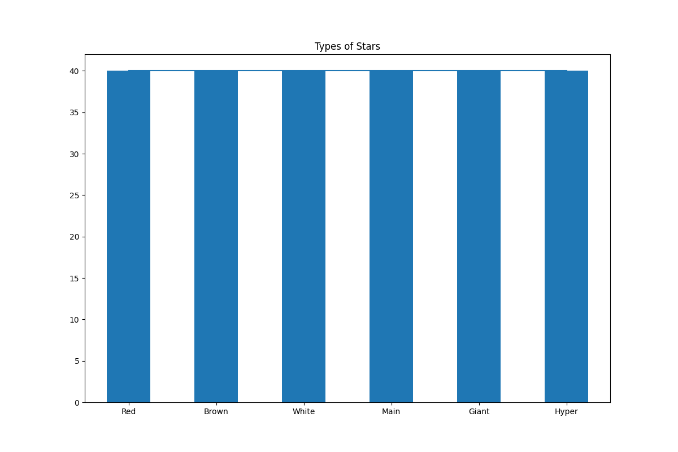

Above shows the number of times a certain color was found in the stars.

Section II: Integration Testing:

We are not integrating this with another system so there is no integration testing to be completed.

Section III: System Testing

The testing was done through a driver program.